AI ASSISTED CODING
ASSIGNMENT-6.3_1557
NAME:T.TEJASRI
HT NO:2303A51557
BATCH:09
Task Description #1: Classes (Student Class)
#create a python class named Student
class Student:
#initialize the class with name and age attributes
def __init__(self, name, age):
self.name = name
self.age = age

#method to display student details
def display_details(self):
print(f"Name: {self.name}, Age: {self.age}")
#create an instance of the Student class
student1 = Student("Alice", 20)
#call the display_details method to show student information
student1.display_details()
#add attibutes name,roll no,branch
student1.roll_no = "101"
student1.branch = "Computer Science"
#print the new attributes
print(f"Roll No: {student1.roll_no}, Branch: {student1.branch}")
#use __init__ to initialize attributes
student2 = Student("Bob", 22)
student2.roll_no = "102"
student2.branch = "Mechanical Engineering"
student2.display_details()
print(f"Roll No: {student2.roll_no}, Branch: {student2.branch}")
#add display_details() to print student info
student2.display_details()
print(f"Roll No: {student2.roll_no}, Branch: {student2.branch}")
student2.display_details()
#create on student object
student3 = Student("Charlie", 21)
student3.roll_no = "103"
student3.branch = "Electrical Engineering"
student3.display_details()
print(f"Roll No: {student3.roll_no}, Branch: {student3.branch}")
#call display_details() method
student3.display_details()
print(f"Roll No: {student3.roll_no}, Branch: {student3.branch}")
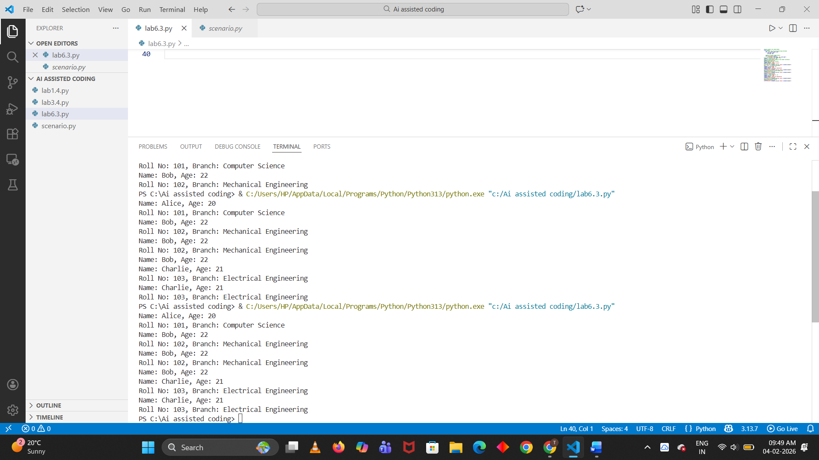
EXPLANTION:
This task creates a Student class to store and display student details like name, age, roll number, and branch using object-oriented programming.
Task Description #2: Loops (Multiples of a Number)
# Write a Python function that prints the first 10 multiples of a given number using a for loop.The number should be taken as user input.
def print_multiples():
num = int(input("Enter a number: "))
print(f"The first 10 multiples of {num} are:")
for i in range(1, 11):
print(num * i)
print_multiples()

# Write the same program to print the first 10 multiples of a given number,use a while loop
def print_multiples_while():
num = int(input("Enter a number: "))
print(f"The first 10 multiples of {num} are:")
count = 1
while count <= 10:
print(num * count)
count += 1
print_multiples_while()
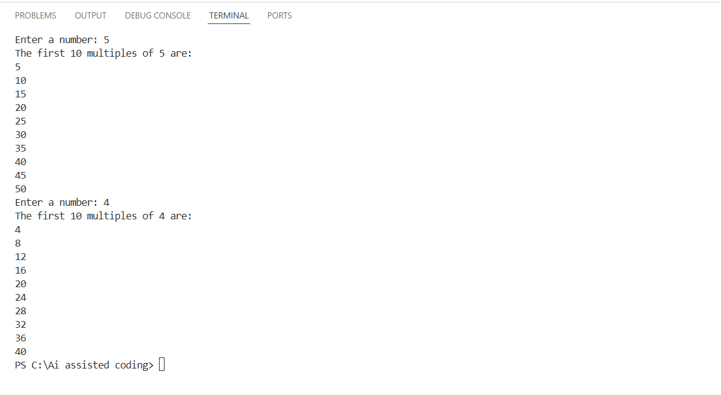
EXPLANTION:
This task uses for loop and while loop to print the first 10 multiples of a given number entered by the user.
Task Description #3: Conditional Statements (Age Classification
#Write a Python function to classify a person's age into groups: child, teenager, adult, and senior.
def classify_age():
age = int(input("Enter the person's age: "))
if age < 13:
print("The person is a child.")
elif 13 <= age < 20:
print("The person is a teenager.")
elif 20 <= age < 60:
print("The person is an adult.")
else:
print("The person is a senior.")
classify_age()

#generate the same classification using alternative conditional structures (e.g.,simplified conditions or dictionary-based logic)
def classify_age_alternative():
age = int(input("Enter the person's age: "))
age_groups = {
range(0, 13): "child",
range(13, 20): "teenager",
range(20, 60): "adult",
range(60, 150): "senior"
}
for age_range, group in age_groups.items():
if age in age_range:
print(f"The person is a {group}.")
break
classify_age_alternative()
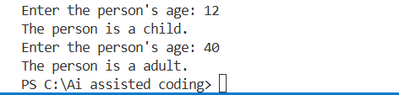
EXPLANTION:
This task classifies a person into child, teenager, adult, or senior based on age using if-elif-else and an alternative dictionary-based method.
Task Description #4: For and While Loops (Sum of First n Numbers)
#Generate a Python function sum_to_n(n) that finds the sum of the first n natural numbers using a for loop.
def sum_to_n(n):
total = 0
for i in range(1, n + 1):
total += i
return total
n = int(input("Enter a natural number n: "))
print(f"The sum of the first {n} natural numbers is: {sum_to_n(n)}")
#Generate the same sum using a while loop
def sum_to_n_while(n):
total = 0
count = 1
while count <= n:
total += count
count += 1
return total
n = int(input("Enter a natural number n: "))
print(f"The sum of the first {n} natural numbers is: {sum_to_n_while(n)}")
#Generate the same sum using the formula n(n+1)/2
def sum_to_n_formula(n):
return n * (n + 1) // 2
n = int(input("Enter a natural number n: "))
print(f"The sum of the first {n} natural numbers is: {sum_to_n_formula(n)}")
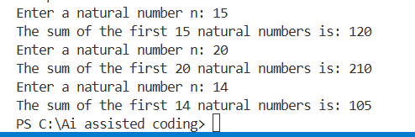
EXPLANTION:
This task calculates the sum of first n natural numbers using a for loop, while loop, and a mathematical formula, and compares the methods.
Task Description #5: Classes (Bank Account Class)
#Write a Python BankAccount class with deposit(), withdraw(), and check_balance() methods
class BankAccount:
def __init__(self, initial_balance=0):
self.balance = initial_balance

def deposit(self, amount):
if amount > 0:
self.balance += amount
print(f"Deposited: ${amount}")
else:
print("Deposit amount must be positive.")

def withdraw(self, amount):
if 0 < amount <= self.balance:
self.balance -= amount
print(f"Withdrew: ${amount}")
else:
print("Insufficient funds or invalid withdrawal amount.")
def check_balance(self):
print(f"Current balance: ${self.balance}")
# Create an instance of BankAccount
account = BankAccount(100) # Initial balance of $100
account.check_balance()
account.deposit(50)
account.check_balance()
account.withdraw(30)
account.check_balance()
account.withdraw(150) # Attempt to withdraw more than the balance
account.check_balance()
# Demonstrate the functionality of each method
account.deposit(-20) # Attempt to deposit a negative amount
account.check_balance()
account.withdraw(50)
account.check_balance()
account.deposit(200)
account.check_balance()
account.withdraw(100)
account.check_balance()
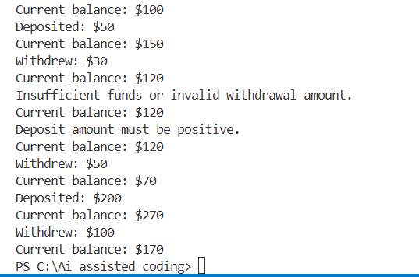
EXPLANTION:
This task creates a BankAccount class with methods to deposit, withdraw, and check balance, showing how basic banking operations work.

